Chapter 9, Solution 54.

In the circuit of Fig. 9.61, find V_{s} if I_{o} = 2∠0° A.

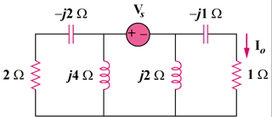

Figure 9.61
For Prob. 9.54.

Solution

Since the left portion of the circuit is twice as large as the right portion, the equivalent circuit is shown below.

Z

2 Z
+

–

V₂

+

+

V₁
–

V_{s}

V₂ + V_{s} + V₁ = 0 or
= (6180)(1.4142–45)

8.485135 V

